
SIA PS Komerc Ltd.
Riga, LV-1046, Latvia
Ph.: +(371) 67440457

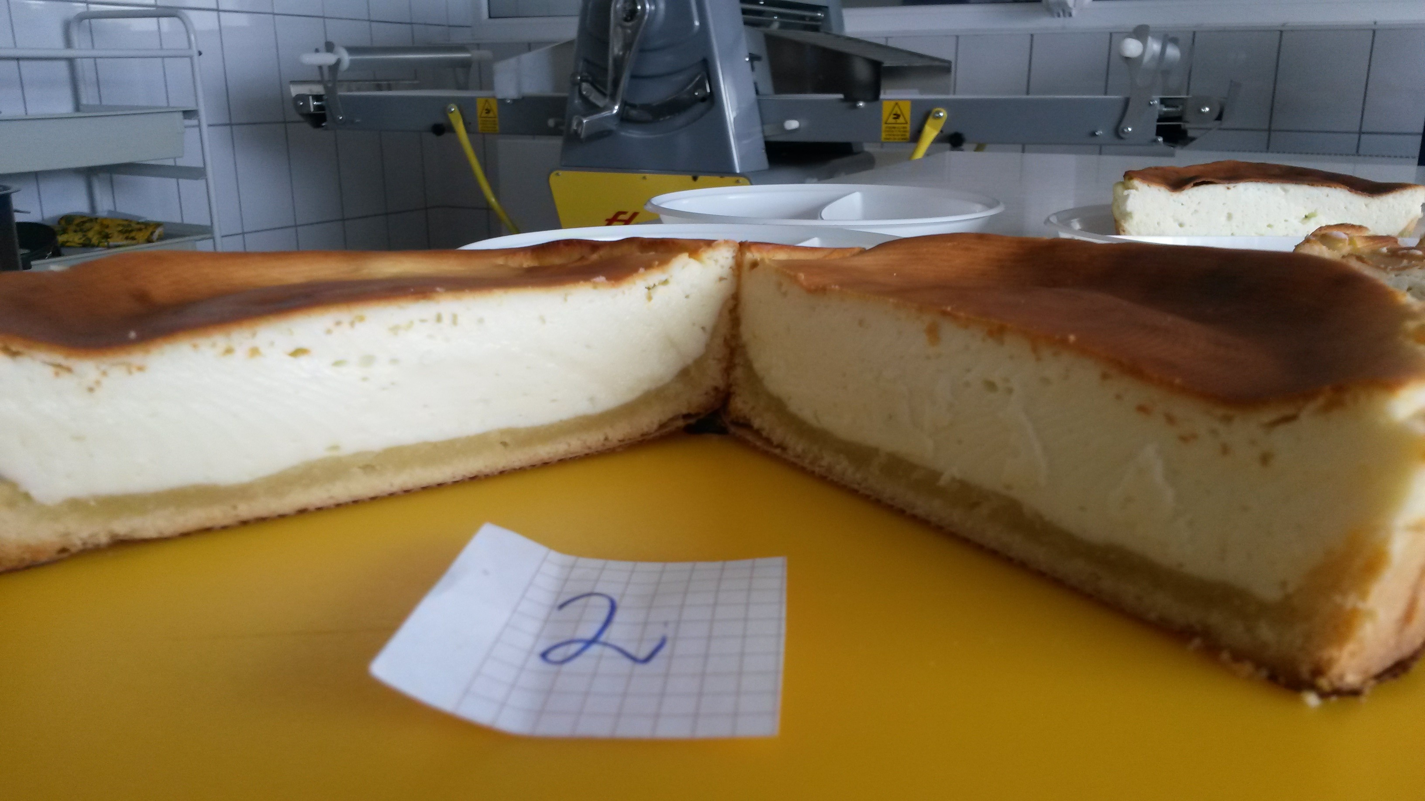
Cheese cake

29-09-2015

INGREDIENTS | g | %
Cake dough
Butter 82 % fat | 140 | 26,57
Sugar | 30 | 5,69
Sour cream 15 or 20 % fat | 100 | 18,98
Flour | 250 | 47,44
Baking powder | 5 | 0,95
Salt | 2 | 0,37
Total | 527 | 100,00
Cake TOPPING
Qurk ( separeted or UF) | 500,02 | 76,13
Sugar | 120 | 18,27
Vanilla flavour T 0435 | 1,2 | 0,18
Salt | 0,6 | 0,09
PSK MIX 0019-1 | 35 | 5,33
Total | 656,82 | 100,00

RAPS, DUPONT , FIRMENICH, Cargill– OFICIĀLAIS PĀRSTĀVIS LATVIJĀ – PS KOMERC
Ar cieņu
Venita Cīrule

